Diaphragmatic Breathing

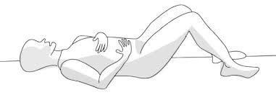

- Lay on the floor and place a book on your tummy.

- As you breathe in through the nose, feel the book rise. As you breathe out through the nose, feel the book fall. Imagine your belly as a balloon, expanding and deflating.

- Do not push or pull the movements. Allow it to happen. Guide the movements with your mind. Focus on slowing down the breathing.

Practice at home for 15 minutes, once daily. It is best to practice this before bedtime.

