Decongest Nose
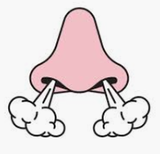
First, check which side of your nose is more congested. Block one nostril with your finger and breathe through the other. Then switch nostrils. This will give you feedback as to how congested or decongested each side of your nose is.

- Sit up straight. Imagine there is a string pulling you upwards from the crown of your head towards the ceiling.
- Take a normal breath in and out through your nose
- Pinch your nose on the exhale with your fingers to hold your breath. Keep your mouth closed.
- As you hold your breath, move your body or gently nod your head up and down.
- Hold your breath for as long as you can until you feel a strong desire to breathe.
- Let go of your nose and breathe gently through it, in and out, with your mouth still closed.
Repeat 6 times with 30-60 seconds rest between each.

After the breath hold try to have the first breathe be an inhale. If you exhale after the breath hold you are releasing all the awesome stuff you built up in the nose, including Nitric Oxide. Nitric Oxide helps to shrink congestion down in the nose.

