Reduced Volume Breathing
Cupping the Nose
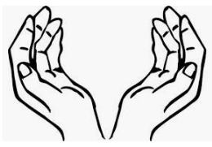

- Sit up straight. Imagine there is a piece of string pulling you upwards from the crown of your head towards the ceiling
- Cup your hands against your face, with hardly any gaps between your fingers.
- With your hands cupping your face, breathe just enough air to fill your nostrils and no more.
- Continue to take a small breath into your nose and allow a small breath out through your nose. It is almost as if you are hardly breathing at all.
- As you reduce and slow down your breathing you will begin to feel a mild need for air. Try to maintain this need for air for about 4 minutes. It should be distinct without being stressful. If the need for air is not distinct then continue to gently reduce your breathing further. If the need for air is too stressful then allow your body to relax and take in a little more air with each breath.

Try to maintain this exercise for 4 to 5 minutes.

