Reduced Volume Breathing
Hand on Chest and Tummy
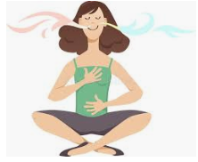

- Sit up straight. Imagine there is a string pulling you upwards from the crown of your head toward the ceiling.
- Place one hand on your chest and one on your tummy.
- Slow down the speed of air as it enters your nostrils. Breathe so gently that hardly any air enters your nose. Breathe so soft that the fine hairs within your nose do not move.
- As you breathe out, bring a feeling of relaxation throughout your body. After you breathe out, wait until you feel the need to breathe in again. Then take a soft, slow, gentle breath in. At the top of the breath, allow a relaxed slow gentle breathe out. Concentrate on slowing down your breathing so that you are taking less air into your body.
- As you reduce and slow down your breathing you will begin to feel a mild need for air. Try to maintain this need for air for about 4 minutes. It should be distinct without being stressful. If the need for air is not distant then continue to gently reduce your breathing further. If the need for air is too stressful then allow your body to relax and take in a little more air with each breath.

Try to maintain this exercise for 4 to 5 minutes.

