BOX BREATHING

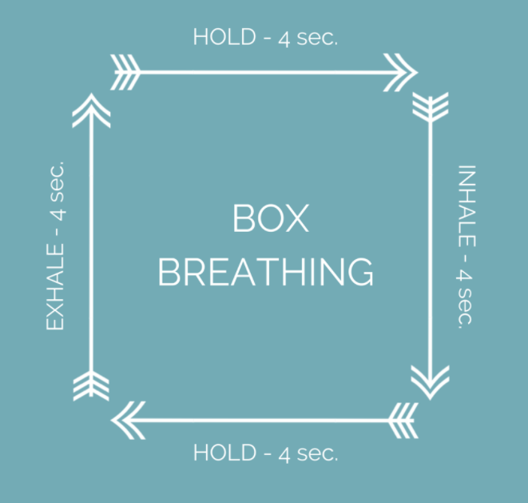

- Inhale to a count of 4; hold 4; exhale 4; hold 4.
- Repeat.
- This should be performed 6 times, once a day.

