Steps
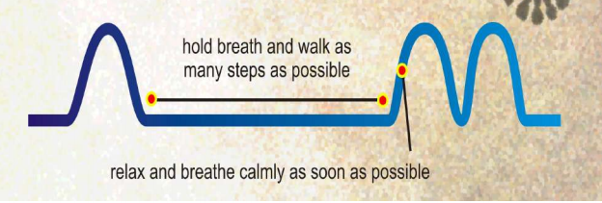

- Take a small breath in and out through your nose.
- Pinch your nose on the exhale with your fingers to hold your breath.
- Walk for 5-10 steps while holding your breath. Try to build up as many steps as you can without losing control of your breathing.
- Stop walking. Breathe in through your nose and rest for 30 seconds or so while standing still.
- After completing your steps your first breath will be bigger than usual. This is normal. Simply ensure you breathe calmly as soon as possible.

Practice 6 repetitions of this exercise up to 2 times a day.

